May 2-5: Monday to Thursday
May 9-12: Monday to Thursday
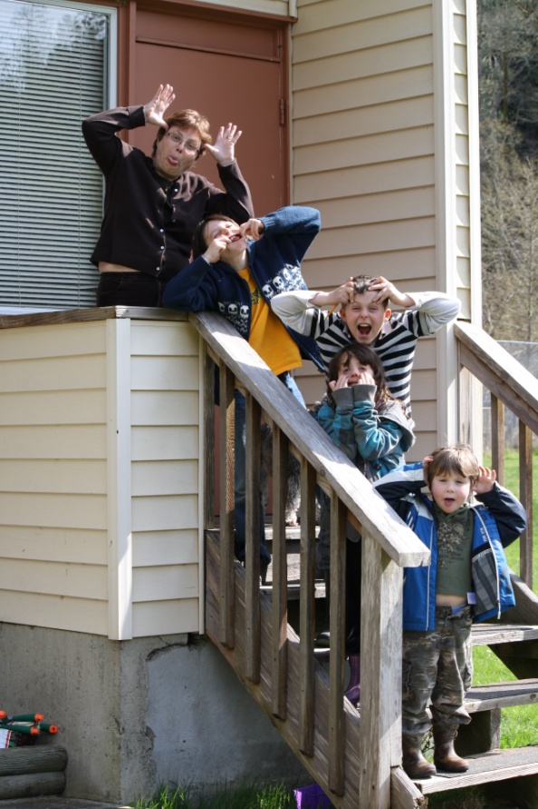

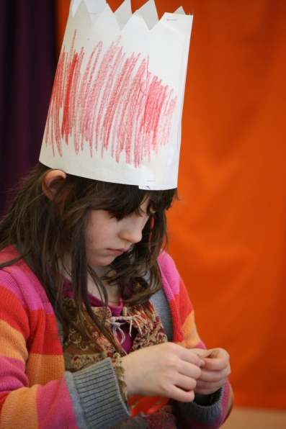

It’s not all hard work...

Bike Rodeo

We will join students from Mayne Island School for a day about bicycle safety on June 9th. The RCMP boat will transport us to the event. There will be a BBQ lunch, each bicycle will be inspected for mechanical safety, the children will go through a bicycle course demonstrating their knowledge of road signs, hand signs and other riding skills. The students will have a bike ride in the afternoon. The grades 4-8 students will go on a longer ride while primary students stay close to the school. We will make arrangements for students’ bikes to be on Mayne. More details will follow...
Upcoming Events...

May 10th, 11th and 12th - Spring Leaves (Homeschoolers from Pender) we will be joining them at the SEEC site.

May 18th PAC Meeting

May 13th. District Planning/Retirement Lunch on Salt Spring Island at GISS

June 2nd Sports Day on Galiano

June 9th Bike Rodeo on Mayne Island

August 15th to 19th - GICEL on Saturna

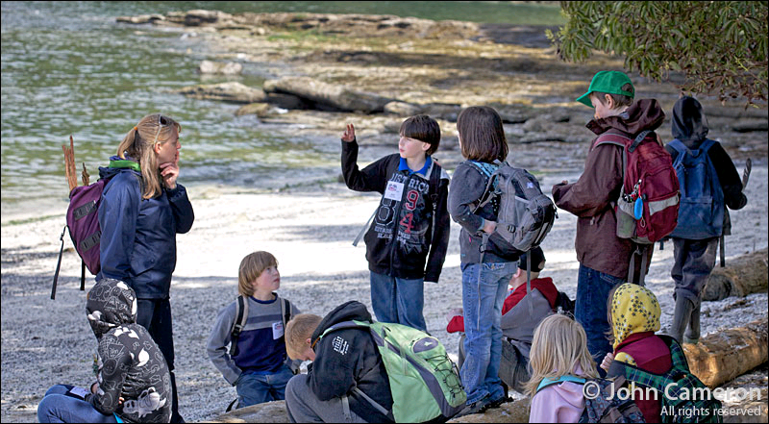
District Day...

District Planning/Retirement Lunch

Please remember to let me know by May 5th if you will be attending District Day. All parents are encouraged to attend. In our school group sessions we talk about our mission statement and future plans for our school. Your input is very valued.
Aboriginal Day...

On April 29th we were treated to a wonderful day on Galiano Island. We were at Montague Marine Park. The weather cooperated all day. We enjoyed drumming, storytelling, a fascinating talk on middens and other archaeological information and a short hike with a conservancy member to identify local plants and their significant to traditional aboriginal people. We had a fabulous salmon BBQ and finished our day playing “Kick the Can” with students from Mayne, Galiano and Pender Islands. Thank you Brent for the boat ride, it was a special treat at the end of the day.

We are all learning to play basic rhythms on drums during our group music sessions. It is great fun.



Sunday May 8th

